Plaza Premium Group Completes Initial Strategic Expansion of Airport Lounges and Airport Dining in Southwestern China
- The third Plaza Premium Lounge and JON Ramen located in the domestic departure hall of Chongqing Jiangbei International Airport officially opened on July 14, 2024, marking the successful launch of Plaza Premium Group's first step in expanding its strategic footprint in southwestern China.
- Plaza Premium Lounge and Jon Ramen in both domestic and international departure areas opened in November 2023 and April 2024, respectively.
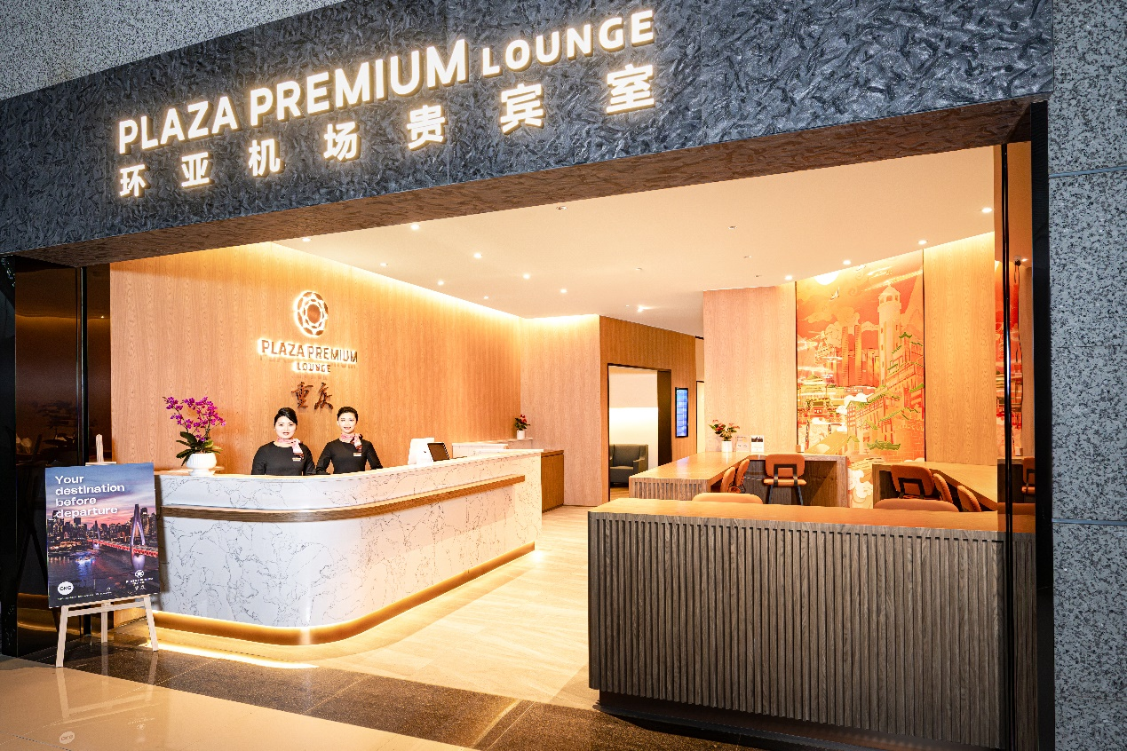
Plaza Premium Lounge at Chongqing Jiangbei International Airport, Terminal T3A Departure Hall
Chongqing, China, July 24, 2024 – Plaza Premium Group(PPG), the award-winning global airport hospitality leader, announced the completion of its expansion project in Chongqing with the opening of its third Plaza Premium Lounge, which is integrated with an airport dining establishment - Jon Ramen at Chongqing Jiangbei International Airport. This new location, situated at the departure hall (Landside), marks our third location in Chongqing Jiangbei International Airport. It follows the previous openings of the first Plaza Premium Lounge and Jon Ramen at Pier E, Domestic Departures (Airside) in November 2023 and the second one at Pier H, International Departures (Airside) in April 2024.

The Chongqing Jiangbei International Airport project signifies PPG's expansion into southwestern China while reinforcing its strategic presence in the Chinese market. It also marks PPG's innovative collaboration with a renowned chain restaurant brand in China for the first time in the region, as well as opening its first international departure lounge in China, fulfilling its brand mission of "Together, We Make Travel Better."

“The Chinese travel market is a dominant force in the world, and we are proud to be able to expand on our lounge, dining and concierge services for travelers in the dynamic southwestern region,” said Regional General Manager – North Asia Jenny Zhang. “We not only want to cover all aspects of the needs of travelers at the airport, but to use our presence as an opportunity to promote the location’s culture, cuisine and traditions in our Proudly Local initiative.
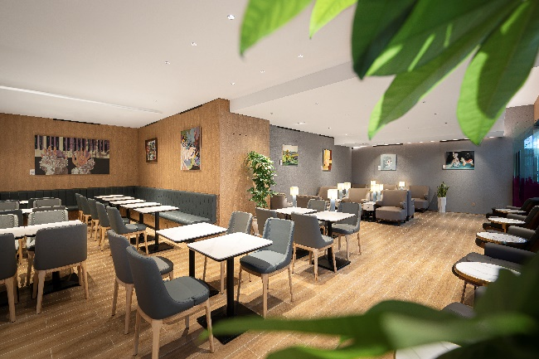
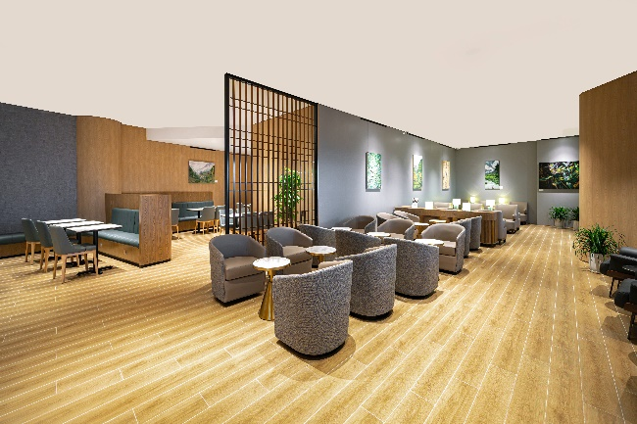

Chongqing Plaza Premium Lounge (Pier H) Chongqing Plaza Premium Lounge (Pier E)

Lounge Overview:
The newly opened lounge is located on the 5th floor of the departure level in Terminal T3A landside, behind Check-in Counter 3C, spanning 185 square meters and accommodating up to 35 guests. Unlike traditional lounges, PPG has partnered with a renowned ramen chain in China for the first time, housing both Plaza Premium Lounge and Jon Ramen under one roof. This collaboration offers a unique hospitality experience for travellers.
The lounge features sleek and comfortable sofa seating, a serene work environment, flight information displays, and charging facilities. Additionally, a multi-functional meeting room capable of hosting up to 22 people caters to the diverse needs of business travelers.
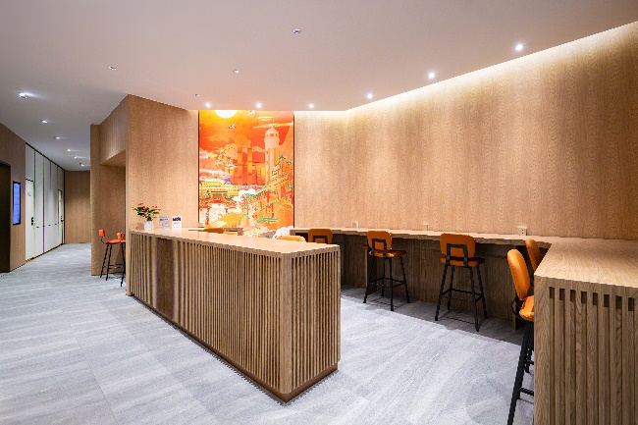 | 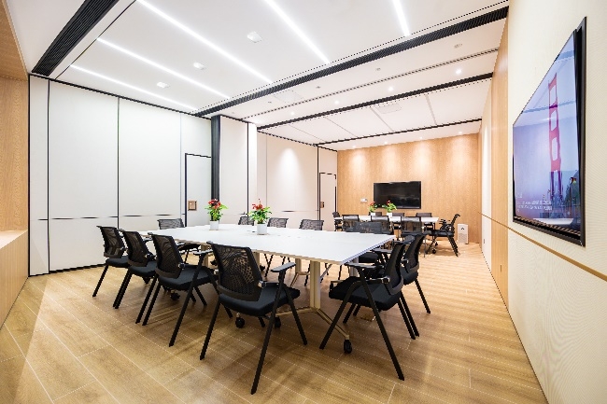
Lounge reading area | Meeting room

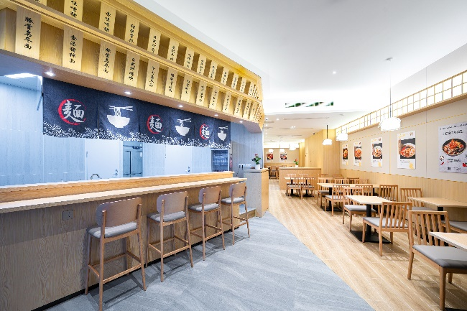
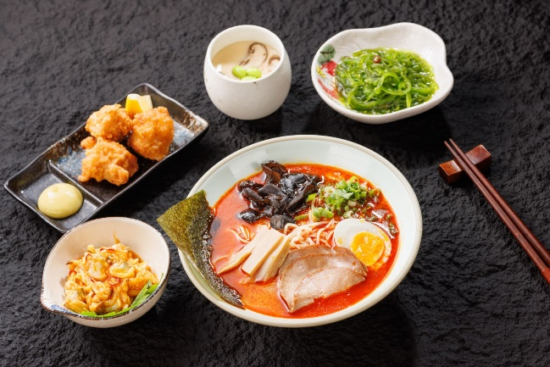

Jon Ramen (Landside) Dining Area Jon Ramen Red Devil Set

Dining Concept:
Abandoning the traditional buffet concept, PPG has partnered with renowned domestic dining brands for the first time. Travelers can indulge in various Japanese ramen and rice bowl set meals, assured that every dish is freshly prepared, delicious and nutritious. Incorporating the local culinary culture of Sichuan and Chongqing, PPG has developed spicy new dishes for travelers to Chongqing while preserving the rich essence of Japanese ramen, offering dishes such as Tonkotsu Ramen and Unagi Donburi. This marks the beginning of a new era of international, localised, digital, and sustainable dining concepts in lounges.
Cultural Initiatives:
• In November 2023, Plaza Premium Group launched "Art & Lounge" in China for the first time, collaborating with outstanding young artists from Sichuan Fine Art Institute, one of China's 8 major art academies, to provide a platform for emerging artists to showcase their talents. This continues the Group's successful "Art x Lounge" projects in Dubai, London, and Kuala Lumpur.
• In July 2024, Chongqing initiated the "Culture & Lounge" project, promoting sustainable development, fulfilling social impact, and advancing an ESG culture. We showcase award-winning photos from an employee-led eco-themed photography competition, encouraging travelers to join us in creating a beautiful environment.
• In coming months, the departure hall lounge will collaborate with Chongqing Jiangbei International Airport (CKG) and the local communities to create a unique and exclusive "Community & Lounge" space in the airport. This space will host regular events for travelers, airport communities and related organisations, including social welfare activities, professional training, and cultural exchanges.
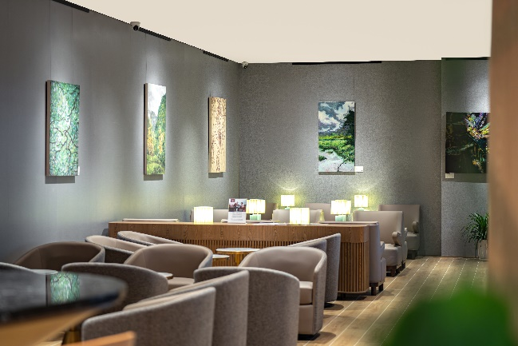
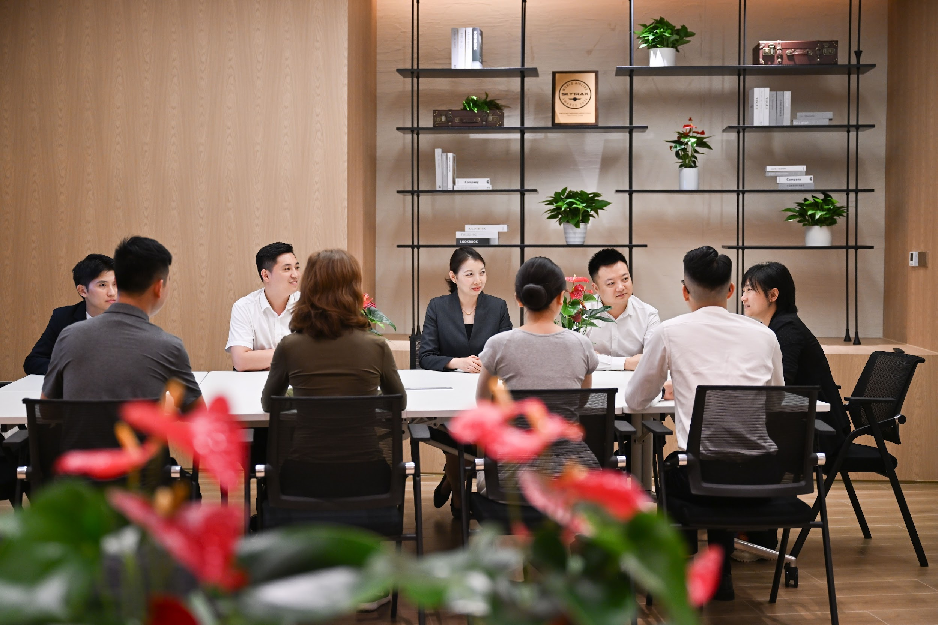

Community & Lounge Concept Art & Lounge Concept

Concierge Services: To create a holistic journey for travellers, we will establish a professional concierge team at Jiangbei International Airport, offering comprehensive services to complement the Plaza Premium Lounge experience, including paid transit services, baggage handling , fast-track security, and customized travel assistance for special needs passengers. Additionally, PPG will soon introduce buggy car service at Chongqing Jiangbei International Airport to enhance passenger experience.
-End-
For more details and booking, please visit:
https://www.plazapremiumlounge.com/en-uk/find/china-regions/mainland-china/chongqing/chongqing-jiangbei-international-airport/departures-landside
Download high-res images here:
https://www.dropbox.com/scl/fo/yxzz6lio2jvotuoog2b4p/ANaaFi_SSeWmGHJGF3Kwtjw?rlkey=839j8a5tjg11faemw2e3liz0k&st=57m30337&dl=0
Media Contact:
Ada Jin, Head of Marketing - China, Plaza Premium Group
ada.jin@plaza-network.com
Whitney Fung, PR & Corporate Communications - Global, Plaza Premium Group
whitney.fung@plaza-network.com
About Plaza Premium Group
Plaza Premium Group, headquartered in Hong Kong and established in 1998, is a pioneering global airport hospitality services provider. With a mission to Make Travel Better, the group introduced the world's first independent airport lounge concept.
Today, PPG operates the largest network of international airport lounges worldwide and offers a 360-degree airport experience with 13 brands under its portfolio, spanning over 1600 touchpoints across more than 80 international airports and 30 countries & regions worldwide.
From airport lounge brands - Plaza Premium Lounge & Plaza Premium First, to terminal hotels - Aerotel & Refreshhh by Aerotel, to concierge services - ALLWAYS, a range of airport dining concepts, global reward and membership program - Smart Traveller, and travel experience ECOsystem - oneTECO, the group is at the forefront of transforming airport experience for the better through innovative and human-led solutions. PPG’s commitment extends beyond its own brands, as it also provides lounge management and hospitality solutions to leading airlines, alliances, and corporates worldwide. Partnerships include renowned names such as American Express, Capital One, Cathay Pacific Airways, SkyTeam, Star Alliance, Visa, and many more.
Plaza Premium Group has over 80 accolades demonstrating its exceptional achievements and commitment to service excellence. Notably, the group has received the prestigious "World's Best Independent Airport Lounge" award at the World Airline Awards by Skytrax for eight consecutive years from 2016 to 2024. TTG Asia also recognized the group as the "Best Airport Lounge Operator" in 2018, 2019 and 2023. In 2020, it achieved the "ISO 9001:2015" certification for its Hong Kong Headquarters. Furthermore, the group's Founder and CEO, Mr. Song Hoi-see, was awarded the “Ernst & Young Entrepreneur of the Year” and “Master Entrepreneur of the Year Malaysia” in 2018.
With a team of over 5,000 dedicated talents, PPG serves more than 20 million global passengers annually. Through a continuous pursuit of innovation and excellence, the group is experiencing exponential growth globally.
To learn more: https://www.plazapremiumgroup.com/
Connect with us: FB, IG, @plazapremiumlounge and WeChat @PlazaPremiumGroup

