Intervals, Plaza Premium Group’s Award-winning Airport Bar Introduces Digital Guest Shift Series - “Cocktail Globetrotting” - Spotlighting World’s Best Bartenders

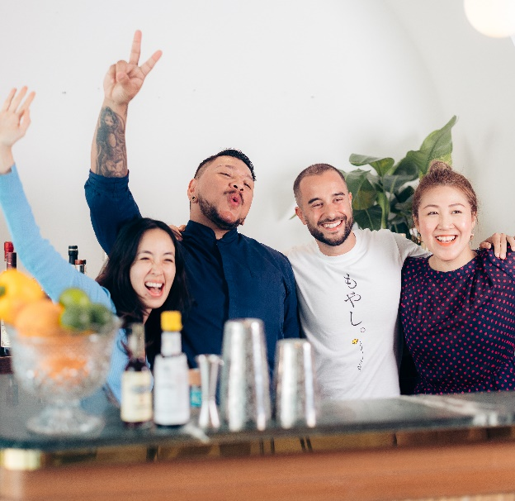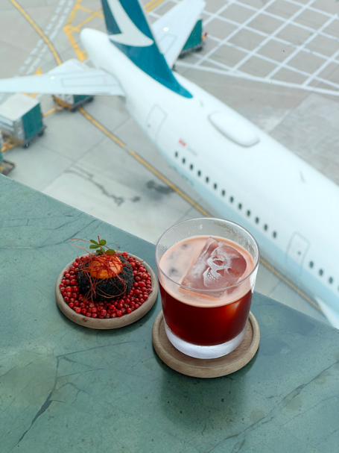

(ANGO by Hope & Sesame, Guangzhou; Oo-Meshu Fizz by Mandala Club, Singapore)

(Hong Kong, 8 August 2024) Intervals, the award-winning airport cocktail bar concept by the leading global airport hospitality services provider Plaza Premium Group, is launching a brand new cocktail series of virtual bar takeovers – “Cocktail Globetrotting”.
Intervals is a unique airport destination that was introduced last year during PPG’s 25th anniversary. Located at the top of the skybridge of Hong Kong International Airport, the concept was curated to bring an innovative experience to the airport and reinforces PPG's mission to make travel better.

The new “Cocktail Globetrotting” series features an award-winning agenda of celebrated bartenders, spotlighting notable bars, bartenders and their signature creations from around the world. Guests are invited to take in a fully immersive experience of a traditional bar guest shift with monthly rotating cocktails prepared on-site, accompanied by a “live” video from respective bartenders at different locations. Here, they will share inspirations behind their concoctions, along with top travel recommendations within their home cities. This exciting initiative aims to further reinvent airport transits with a far-flung beverage adventure before even boarding a plane.

“The airport is a destination where every journey begins. For us, it is important to keep innovating and instilling creativity into what we do, offering unique and engaging experience for travelers. At PPG, we place a strong emphasis on culture, connections to the destinations, while providing a platform to showcase talents. We also create experiences based on travelers’ needs and travel triggers. Bar-hopping is a popular activity among tourists looking to explore a city's nightlife and culture, with the Cocktail Globetrotting campaign, you don't necessarily have to travel all the way to specific cities to visit their renowned bars. We bring their famous cocktails to you,” said Mei Mei Song, Plaza Premium Group’s Director of Global Brands and Transformation and Co-creator of Intervals.

Kicking off the campaign on the 15th of August is one of Asia’s finest bars, virtual guest bartender Andrew Ho from Guangzhou’s Hope & Sesame, ranked 14th on Asia’s 50 Best Bars 2024. Andrew will be serving up the signature ANGO, a twist on the classic Trinidad Sour. Made with aged rum Matusalem Gran Reserva 15 Year as its base, the cocktail is reminiscent of the traditional Cantonese dish of stewed pig’s trotter in ginger and sweetened vinegar, combined with Angostura bitters, a sugar syrup distilled from concentrated Italian balsamic vinegar, lime juice, and beetroot juice for a refreshing mix of sweet-meets-sour.

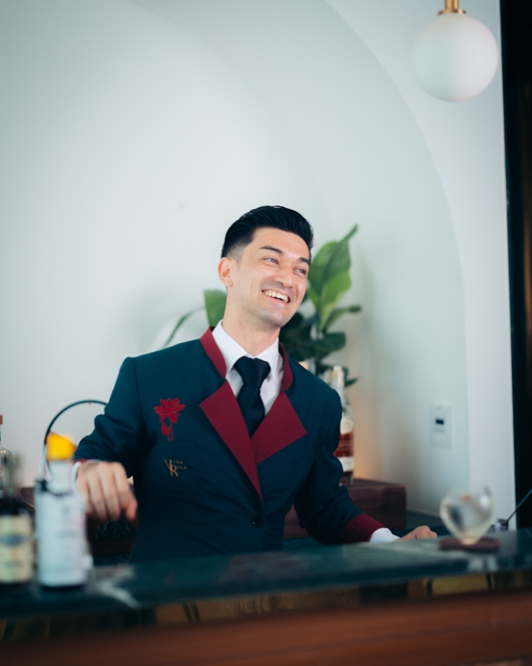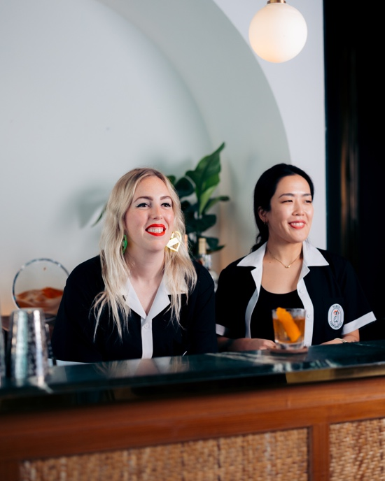

(Davide Boncimino from Vida Rica, Macau; Holly Graham & Waka Murata from Tokyo Confidential, Tokyo)

Following in September is Minakshi Singh from Delhi’s Sidecar —26th on World’s 50 Best Bars 2022 — serving Gondhoraj, an aromatic crowd favourite dedicated to the Bengali lime made with a Tanqueray base, a Sidecar-special gondhoraj mix and tonic water. The month of October will see creations from one of Singapore’s finest bars. Bar Manager Diveysh Ramesh from Singapore’s coveted Mandala Club shakes up the Oo-Meshu Fizz, which brings forward the natural flavours of umeshu with milk, oolong, and Azumaichi Honkaku Umeshu Nautrale.

From further beyond the region is Mexico’s Rayo, ranked 17th on North America’s 50 Best Bars, which explores the expansive world of local Mexican spirits. Co-founders Alvaro Garcia and Tito Pin-Perez serve up a spirit-heavy sampler with Number 1 in November, an alternative take on the Old Fashioned with 7 Misterios Mezcal Espadín mezcal, Matusalem Gran Reserva Rum 15 Years, Amaro Averna, and a savoury burst of beef, bacon, vegetable lacto ferment, beer, and cilantro.

Rounding out 2024 in December is a very special treat from Tokyo Confidential founder and erstwhile Hong Kong-er Holly Graham. Created by Holly and Head Bartender Waka Murata, the Tokyo based team present a boozy take on a beloved Hong Kong street snack. The Cheung Fun Old Fashioned is the perfect balance of sweet and savoury with peanut- and sesame-infused bourbon, orange and Angostura bitters, finished with a dash of soy caramel.

Kicking off the new year, Kuala Lumpur’s Penrose, currently ranked 8th on Asia’s 50 Best Bars 2024, will showcase the Penrose Gibson by founder and Head Bartender Jon Lee, which is an enduring signature with a homemade leek brine recipe paired with gin, Sake Junmai, Tio Pepe, and a dash of Naked Malt Scotch Whisky.

From Macau, Davide Boncimino of Mandarin Oriental’s Vida Rica presents the ever-refreshing Ginger Snaps in February. A heady cocktail of Roku gin, Bianco Vermouth, and elderflower liqueur, it’s brightened by a splash of guava juice and lemon juice before a satisfying kick of heat from fresh-pressed ginger juice and ginger beer.

Rounding out the global cocktail tour in March 2025, Ronnaporn K., co-founder of Bangkok’s Mahaniyom Cocktail Bar, currently ranked 18th on Asia’s 50 Best Bars 2023, transports guests to sunny Bangkok with the refreshing Kaffir Lime drink. Prepared with different variations of the zesty fruit, it features kaffir lime leaves-infused vermouth and kaffir lime agave cordial with Fernet Branca and tonic water.

In addition, sumptuous food pairings have been created to complement each of these signature cocktails, maximizing the airport dining experience. Guests will also receive a pocket-sized travel guide to the city of their respective cocktail order filled with recommendations of the best spots to visit, tips on local drinking culture, and favourite watering holes from industry professionals. Each edition will later be compiled into a single book to create the Ultimate Intervals Guide.

Intervals’ “Cocktail Globetrotting” event is an eight-month-long series that will run from August 2024 to March 2025, launching on 15 August 2024 and rotating on every 15th of the month until the end of the campaign.

For high-res imagery please click HERE.

- END -

Editor’s Note

Level 9, Sky Bridge, Hong Kong International Airport
Proceed up the escalator between Gate 12 & 24
Open Daily, 7am – 11:30pm

T: +852 6706-8075
hkg@intervalsbar.com
www.intervalsbar.com
IG @intervalsbar
For more information, please contact:
Alex Berry: Alex@companioncommunications.com
June Heung: June@companioncommunications.com
Dominique Backhouse: Dominique@companioncommunications.com
About Intervals

Located at Hong Kong International Airport’s Skybridge, Intervals is a world-class cocktail bar from Mei Mei Song of Plaza Premium Group and bar-industry veteran, Victoria Chow. Inspired by the idea that the time of day in an airport becomes fluid and Plaza Premium Group’s core mission to “make travel better”, Intervals is a comprehensive F&B concept purposefully designed for the airport setting with artisanal cocktails coupled with interactive and engaging experiences, set against a backdrop of immersive interior design and the unbeatable Skybridge view that is a destination in itself.

Made up of a series of miniature drinks, known appropriately as a ‘flight of cocktails’, Intervals’ drinks programme has been tailored to how much time a guest has to spare ranging from a 15-minute to a 45-minute experience. Intervals also offers food experiences designed to be an elevated and global take on “pinchos”.

About Plaza Premium Group
Plaza Premium Group, headquartered in Hong Kong and established in 1998, is a pioneering global airport hospitality services provider. With a mission to Make Travel Better, the group introduced the world's first independent airport lounge concept.
Today, PPG operates the largest network of international airport lounges worldwide and offers a 360-degree airport experience with 13 brands under its portfolio, spanning over 1600 touchpoints across more than 75 international airports and 30 countries & regions worldwide.
From airport lounge brands - Plaza Premium Lounge & Plaza Premium First, to terminal hotels - Aerotel & Refreshhh by Aerotel, to concierge services - ALLWAYS, a range of airport dining concepts, global reward and membership program - Smart Traveller, and travel experience ECOsystem - oneTECO, the group is at the forefront of transforming airport experience for the better through innovative and human-led solutions. PPG’s commitment extends beyond its own brands, as it also provides lounge management and hospitality solutions to leading airlines, alliances, and corporates worldwide. Partnerships include renowned names such as American Express, Capital One, Cathay Pacific Airways, SkyTeam, Star Alliance, Visa, and many more.
Plaza Premium Group has over 80 accolades demonstrating its exceptional achievements and commitment to service excellence. Notably, the group has received the prestigious "World's Best Independent Airport Lounge" award at the World Airline Awards by Skytrax for eight consecutive years from 2016 to 2024. TTG Asia also recognized the group as the "Best Airport Lounge Operator" in 2018, 2019 and 2023. In 2020, it achieved the "ISO 9001:2015" certification for its Hong Kong Headquarters. Furthermore, the group's Founder and CEO, Mr. Song Hoi-see, was awarded the “Ernst & Young Entrepreneur of the Year” and “Master Entrepreneur of the Year Malaysia” in 2018.
With a team of over 5,000 dedicated talents, PPG serves more than 20 million global passengers annually. Through a continuous pursuit of innovation and excellence, the group is experiencing exponential growth globally.

To learn more: https://www.plazapremiumgroup.com/
Connect with us: FB, IG, @plazapremiumlounge and WeChat @PlazaPremiumGroup

