Plaza Premium Group unveils Infinity Room, a “Lounge within a Lounge” located within Plaza Premium First at Hong Kong International Airport

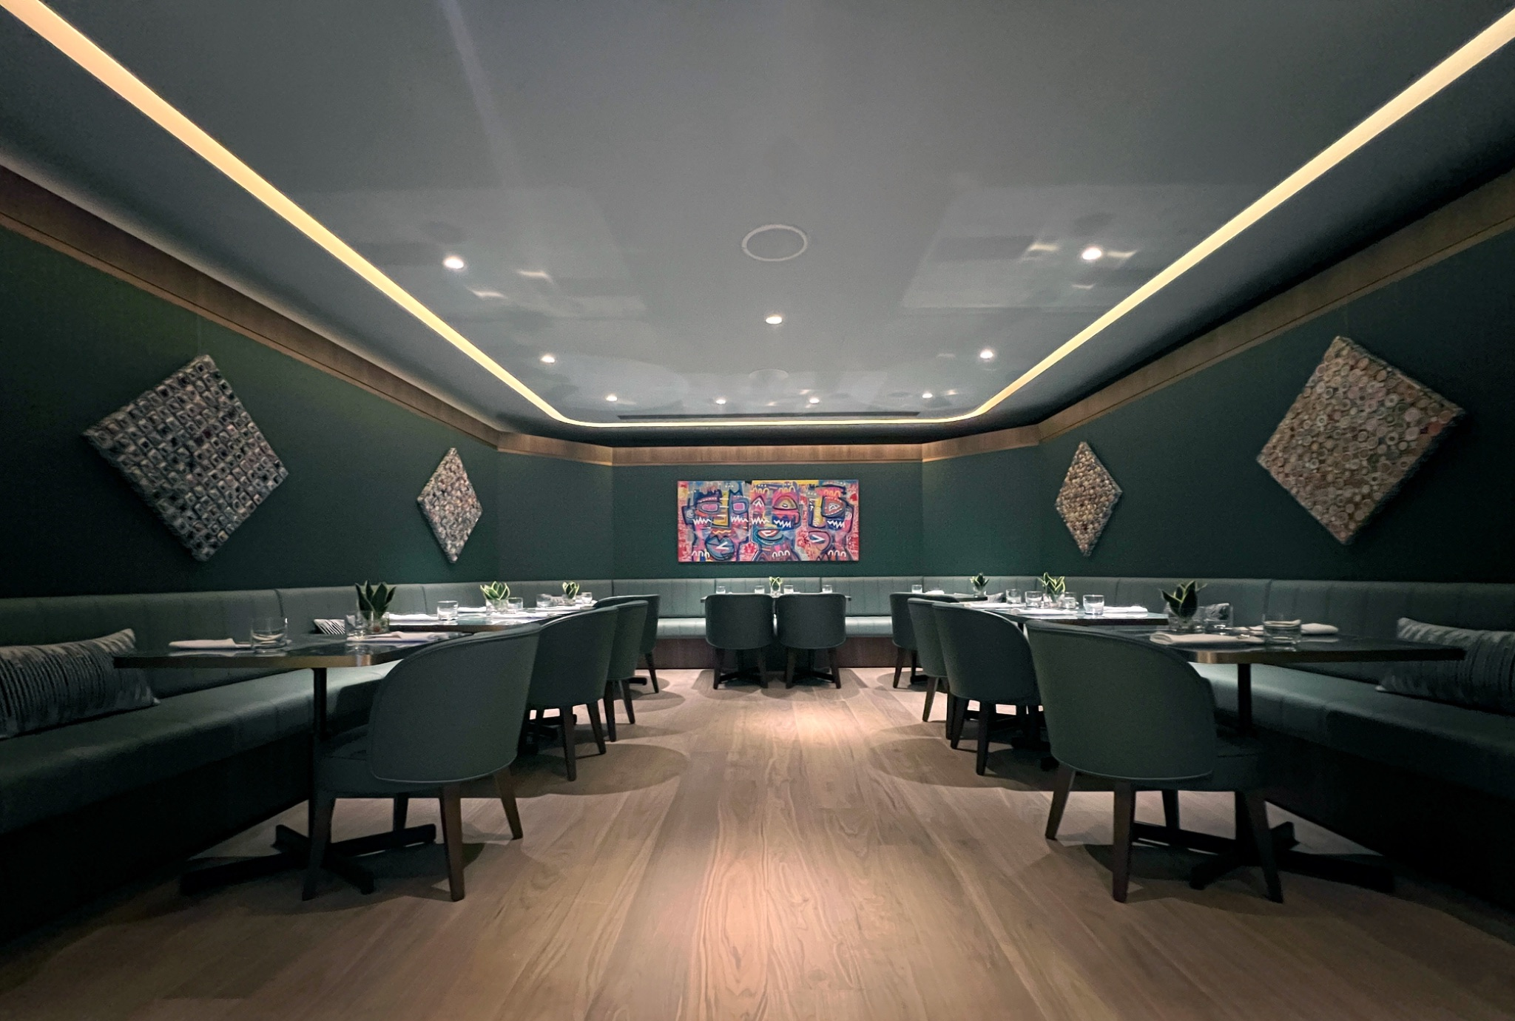

(Hong Kong, 5 Sep 2024) A private haven amidst the busy rush of Hong Kong International Airport, Plaza Premium Group unveils Infinity Room. The brand-new premium VIP passenger lounge offers a sanctuary-like space for a selected class of elite travellers as growing passenger traffic in Terminal 1 soars beyond a new post-pandemic daily height of over 171,000 in July.
A “Lounge within a Lounge”, the recently reopened and renovated Infinity Room is nestled within Plaza Premium First, conveniently located adjacent to Gate 1. The secluded space serves as an extension to the personalised, all-inclusive lounge reserved for invited guests, such as Airline partners’ First Class and Business Class travellers. To experience the ease and comfort of Infinity Room, walk-in guests can also purchase full access to the luxurious first-class service. Guests will enjoy a thoughtfully crafted modern interior, with cosy seating, stylish furnishings, , and a curated selection of contemporary artworks that create an intimate and relaxing ambience.

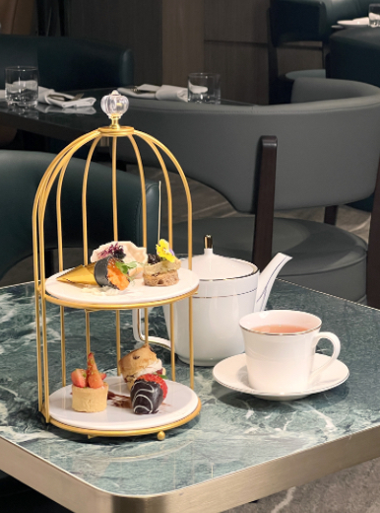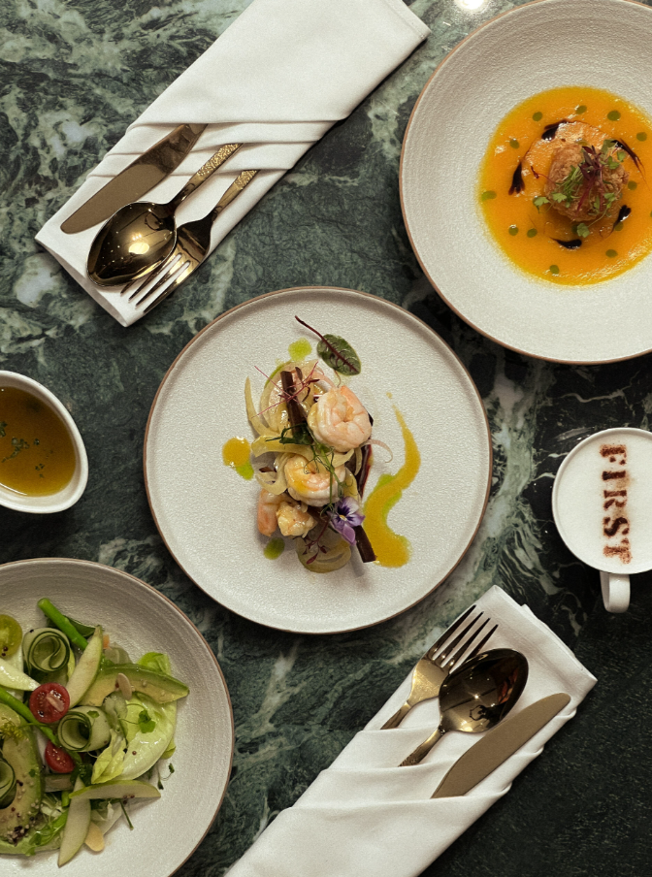
Serving a round-the-clock dining experience, the all-day menu at Infinity Room spotlights local-inspired specialities blending Chinese and Western influences. Guests can savour made-to-order creations from the ever-changing menu with a selection of hearty breakfast favourites available until 11am daily followed by an all-day menu from 11am highlighting sumptuous flavours from various global cuisines. Vegetarian and gluten-free choices are also available, as well as a refined beverage selection of single-malt whiskeys, brandy cognac, wines, spirits, Chinese & Western teas, and juices.

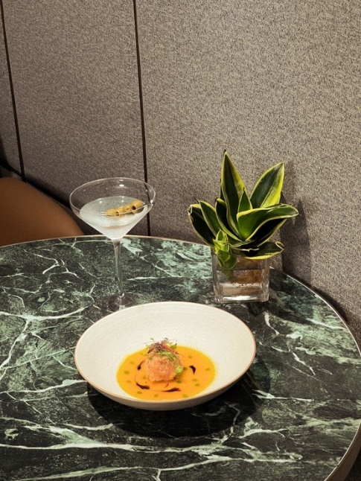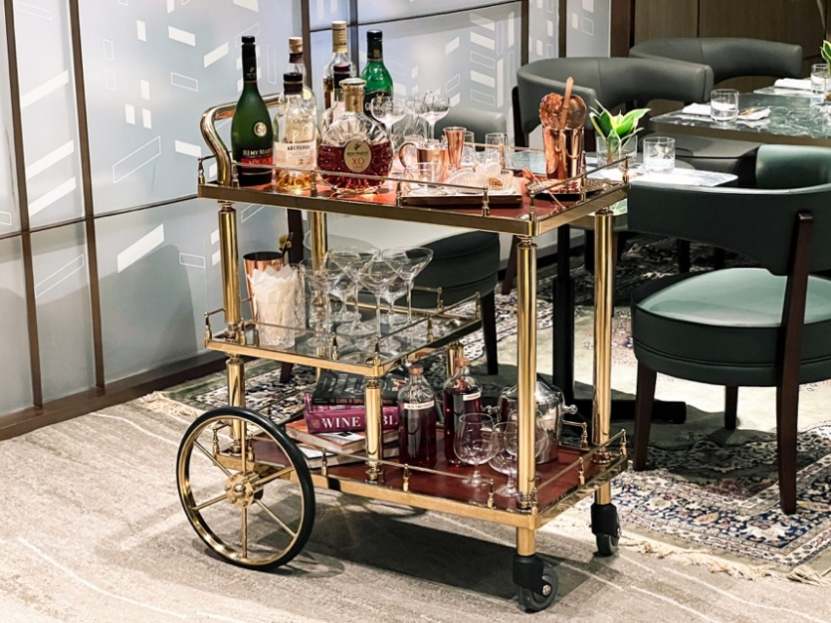

Throughout the day, Infinity Room’s dining offerings rotate accordingly — from high tea in the afternoon of delicate sweet-and-savoury bites served with a premium selection of Chinese and Western loose tea leaves to tapas in the evening and sweet snacks for a late-night indulgence.

Exceptional hospitality is at the heart of Plaza Premium First, which offers travellers a home-like respite to relax, unwind, and freshen up before continuing their journey. Dedicated brand ambassadors attend to every need with round-the-clock personalised service, including the warm greeting of guests to introduce an accommodating suite of on-site amenities which includes shower room facilities and a complimentary 10-minute neck and shoulder massage available for walk-in on a first come, first served basis. Infinity Room’s VIP passenger experience continues beyond the sophisticated lounge space with ALLWAYS’ buggy service, seamlessly shuttling guests straight to their boarding gate for a truly effortless travel experience.
This novel concept aligns with PPG's commitment to make travel better by continuously refining airport hospitality experiences and staying on top of travelers' trends. “At PPG, we transform and innovate with travellers in mind, and there has been a noticeable increase in demand for high-end experiences from affluent travelers, especially those from China and the Middle East. With that in mind, we introduced the "Infinity Room" in Plaza Premium First, a high-end lounge brand under our portfolio designed for elite travelers. This new exclusive space offers enhanced luxury, privacy, and personalised services - attributes that are often rare to find in an airport setting." said Mei Mei Song, Chief Transformation Officer, Plaza Premium Group.
After a debut in Hong Kong, the group hopes to expand the “Infinity Room” concept in other global destinations.

For the full media kit, including high-res imagery & spokesperson bios click HERE.
END
About Plaza Premium First
Level 6, Departures Level, Terminal 1,
Hong Kong International Airport (Near Gate 1)

OPENING HOURS
0630 - 0100 daily

Tel: +852 5700 5329
Enquiry: hongkong@plaza-network.com
Book online: plazapremiumfirst.com

www.plazapremiumfirst.com
IG @plazapremiumfirst

About Plaza Premium Group
Plaza Premium Group, headquartered in Hong Kong and established in 1998, is a pioneering global airport hospitality services provider. With a mission to Make Travel Better, the group introduced the world's first independent airport lounge concept. Today, PPG operates the largest network of international airport lounges worldwide and offers a 360-degree airport experience with 13 brands under its portfolio, spanning over 1600 touch points in 75+ airports and 30 countries worldwide. From airport lounge brands - Plaza Premium Lounge & Plaza Premium First, to terminal hotels - Aerotel & Refreshhh by Aerotel, to concierge services - ALLWAYS, a range of airport dining concepts, global reward and membership program - Smart Traveller, and travel experience ECOsystem - oneTECO, the group is at the forefront of transforming airport experience for the better through innovative and human-led solutions.

PPG’s commitment extends beyond its own brands, as it also provides lounge management and hospitality solutions to leading airlines, alliances, and corporates worldwide. Partnerships include renowned names such as American Express, Capital One, Cathay Pacific Airways, SkyTeam, Star Alliance, Visa, and many more.

Plaza Premium Group has over 80 accolades demonstrating its exceptional achievements and commitment to service excellence. Notably, the group has received the prestigious "World's Best Independent Airport Lounge" award at the World Airline Awards by Skytrax for eight consecutive years from 2016 to 2024.. TTG Asia also recognized the group as the "Best Airport Lounge Operator". In 2020, it achieved the "ISO 9001:2015" certification for its Hong Kong Headquarters. Furthermore, the group's Founder and CEO, Mr. Song Hoi-see, was awarded the “Ernst & Young Entrepreneur of the Year” and “Master Entrepreneur of the Year Malaysia” in 2018.

With a team of over 5,000 dedicated talents, PPG serves more than 20 million global passengers annually. Through a continuous pursuit of innovation and excellence, the group is experiencing exponential growth globally.

To learn more: https://www.plazapremiumgroup.com/

Connect with us: FB, IG, @plazapremiumlounge and WeChat @PlazaPremiumGroup

Press contacts:
Whitney Fung, Plaza Premium Group PR & Corporate Communications
E: whitney.fung@plaza-network.com

Dominique Backhouse – Hong Kong: Dominique@companioncommunications.com
Alex Berry – Hong Kong: Alex@companioncommunications.com

