Plaza Premium Group Opens New Lounge in London Heathrow Terminal 4,
launches ‘Proudly Local’ and fourth series of the ‘Art & Lounge’ in the UK
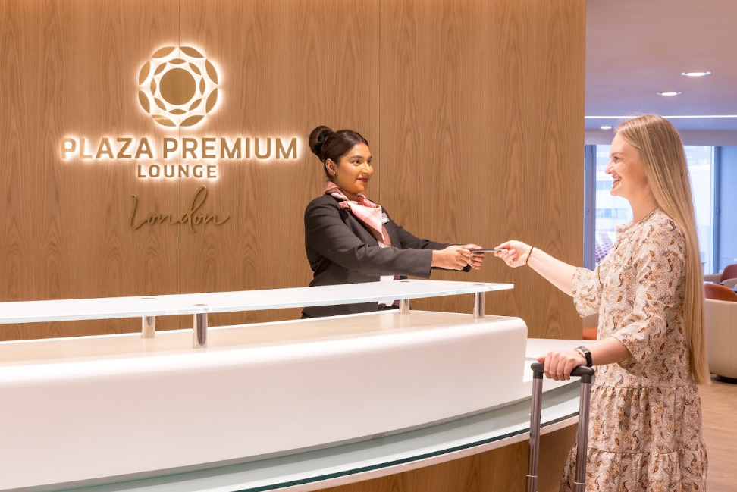
London, 11 October 2024 – Plaza Premium Group, the leading global airport hospitality services provider, has announced the opening of its brand-new state-of-the-art lounge in Heathrow’s Terminal 4 – a key part of the group’s global expansion plan after 10 years in the UK. The opening marks a move from the existing Plaza Premium Lounge to a newly developed and larger space, its fourth location at London Heathrow, and is ideal for travellers looking to elevate their pre-flight experience while enjoying a tranquil escape away from the hustle and bustle of departures.
The beautifully designed 766 square metre lounge, with floor to ceiling runway views and a capacity of 147, offers a quiet zone for business travellers needing to focus. The lounge is designed with subtle nuances to the surrounding city of London. Elements include use of architecture in a simple and stylised way, as well as fun influences from the London Underground tube seat patterns in the furniture and tiles.
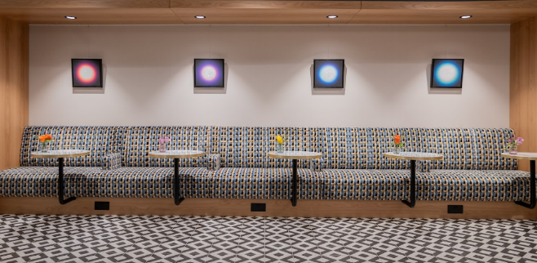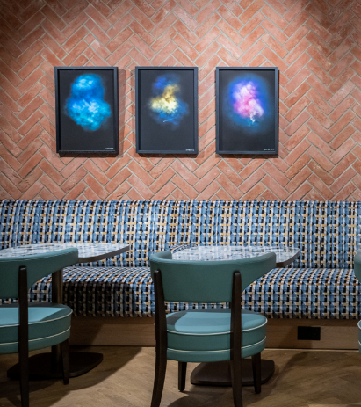
The new opening at Heathrow’s Terminal 4 will be the first Plaza Premium Lounge in the UK to offer the new ‘Proudly Local’ experience that Plaza Premium Group is introducing globally. Aiming to be ‘your destination before departure’, ‘Proudly Local’ offers travellers the chance to learn more about the destination and its culture through art, food, and community. In the lounge, travellers can savour authentic British classics including ‘Victoria Sponge’, ‘Cottage Pie’, ‘Pimm's’ and Gin & Tonic made with locally-distilled Bombay Sapphire and London Essence. An array of international cuisines and complimentary drinks are also available at the buffet station. During festive periods, the lounge will transform into a festive hub, celebrating local traditions and customs with opportunity for guests to get involved in the fun.
Lorenzo Valori, Vice President of Commercial Development and Operations Europe said: “We’re delighted to announce the opening of the new Heathrow Terminal 4 lounge as we celebrate 10 years of Plaza Premium Group in the UK. This is our second opening in London this year, also marking our sixth lounge in the city. London remains one of the world’s most important aviation hubs with strong global connectivity and we are committed to further strengthening our presence here.”
He adds: "London stands as one of the cultural capitals in the world. With the introduction of ‘Proudly Local’, we want our guests to immerse themselves in the city's rich heritage and culture through the experience, ultimately enhancing their journey."
ART & LOUNGE
Plaza Premium Lounge is also thrilled to present the latest Spotlight Art exhibition installed throughout the new lounge and in place for two months from late September. Lauren Baker is an award winning British multidisciplinary and multisensory contemporary artist, living and working in London. The Ascending Horizons exhibition invites travellers on a spiritual journey through an oeuvre of artwork inspired by nature, symbolism, the higher realms of consciousness, mysticism and an exploration of our connection to the universe. Baker is currently featured as part of the Venice Biennale, previously having exhibited at the V&A, Tate Britain and Tate Modern, she is respected for her contribution to public art both in the UK and worldwide.
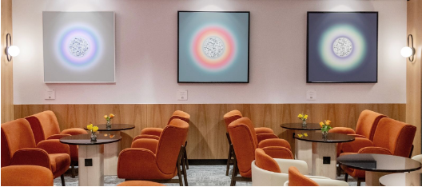
Relax in a stylish setting and admire the captivating Ascending Horizons art exhibition by Lauren Baker.

On display will be new and recent artworks across a variety of media. Including Baker’s signature neon typography, alongside original canvases with superior vibrancy ink, hand embellished with diamond dust, reflective lenticulars, and a selection of limited-edition prints. Artworks are available for sale and travellers interested should contact the Art and Lounge curators for any further information. A percentage of sales will contribute towards Baker’s ongoing mission to plant 8888 trees in the Amazon.
Artist Lauren Baker comments; "Ascending Horizons is a voyage through the boundless expanse of the universe, where each artwork reflects the awe-inspiring mystery of the cosmos. The exhibition explores the crossroads of terrestrial and celestial, whilst contemplating the infinite possibilities that lie beyond the skies and stars."

The exhibition marks the fourth artist to display their work in a Plaza Premium lounge in the UK, with Marcia Scott Flow and Joe Machine Nature extended at locations in London Heathrow Terminal 2 and Gatwick North Terminal.
The lounge at Heathrow Terminal 4 will continue to serve passengers from SkyTeam member airlines, including Air France, KLM Royal Dutch Airlines, China Eastern, Kenya Airways, Korean Air and Saudia Airlines. Additionally, we welcome passengers from Air Algérie, Air Astana, Bulgaria Air, Air Serbia, Biman Bangladesh Airlines, China Southern, Royal Air Maroc, Royal Brunei, RwandAir, Tunisair, Turkmenistan Airlines and WestJet to enjoy our newly refurbished lounge. Holders of selected corporate cards, including American Express, DragonPass, LoungeKey, and Priority Pass, also have access to the lounge. We are also delighted to welcome walk-in travellers to experience our services.

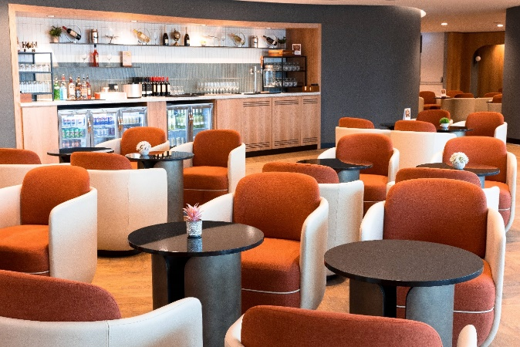 | 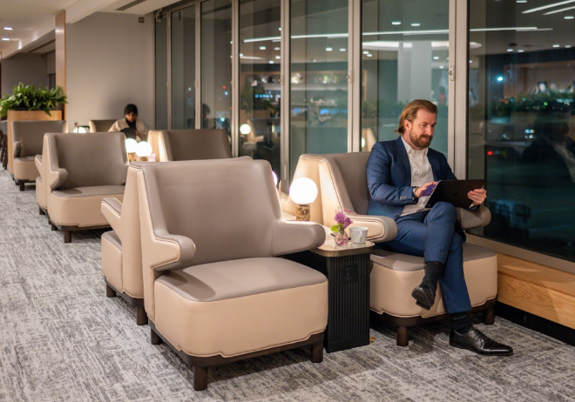

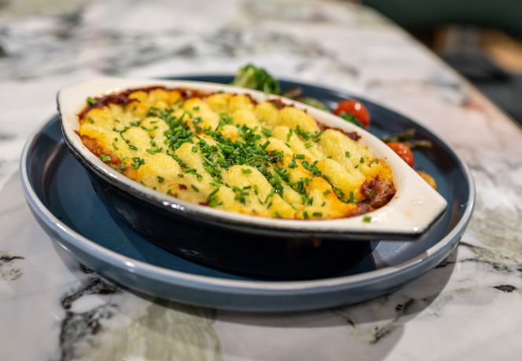 | 
Experience the first ‘Proudly Local’ lounge in the UK, offering a taste of London with delicious regional favourites like the Chef’s Signature Cottage Pie in a relaxing atmosphere and indulge in authentic British cuisine.

ENDS

For further information contact
Louise Burrows - Europe Marketing
louise.burrows@plaza-network.com
Whitney Fung - Global PR & Corporate Communications
whitney.fung@plaza-network.com

For further information on Lauren Baker Ascending Horizons, please contact curators Amie Conway / Alex Cousens hello@spotlight-art.com

Location:
Opposite Gate 10a, Level 2, Terminal 4 Departures, London Heathrow Airport

Download high-res images here.

About Plaza Premium Group
Plaza Premium Group, headquartered in Hong Kong and established in 1998, is a pioneering global airport hospitality services provider. With a mission to Make Travel Better, the group introduced the world's first independent airport lounge concept.
Today, PPG operates the largest network of international airport lounges worldwide and offers a 360-degree airport experience with 13 brands under its portfolio, spanning over 1600 touchpoints across more than 75 international airports and 30 countries & regions worldwide.
From airport lounge brands - Plaza Premium Lounge & Plaza Premium First, to terminal hotels - Aerotel & Refreshhh by Aerotel, to concierge services - ALLWAYS, a range of airport dining concepts, global reward and membership program - Smart Traveller, and travel experience ECOsystem - oneTECO, the group is at the forefront of transforming airport experience for the better through innovative and human-led solutions. PPG’s commitment extends beyond its own brands, as it also provides lounge management and hospitality solutions to leading airlines, alliances, and corporates worldwide. Partnerships include renowned names such as American Express, Capital One, Cathay Pacific Airways, SkyTeam, Star Alliance, Visa, and many more.
Plaza Premium Group has over 80 accolades demonstrating its exceptional achievements and commitment to service excellence. Notably, the group has received the prestigious "World's Best Independent Airport Lounge" award at the World Airline Awards by Skytrax for eight consecutive years from 2016 to 2024. TTG Asia also recognized the group as the "Best Airport Lounge Operator" in 2018, 2019 and 2023. In 2020, it achieved the "ISO 9001:2015" certification for its Hong Kong Headquarters. Furthermore, the group's Founder and CEO, Mr. Song Hoi-see, was awarded the “Ernst & Young Entrepreneur of the Year” and “Master Entrepreneur of the Year Malaysia” in 2018.
With a team of over 5,000 dedicated talents, PPG serves more than 20 million global passengers annually. Through a continuous pursuit of innovation and excellence, the group is experiencing exponential growth globally.

To learn more: https://www.plazapremiumgroup.com/
Connect with us: FB, IG, @plazapremiumlounge and WeChat @PlazaPremiumGroup

