Plaza Premium Group sponsored and participated in the
“Hong Kong International Airport‧Standard Chartered Hong Kong Marathon: Three-Runway System 10km International Race”
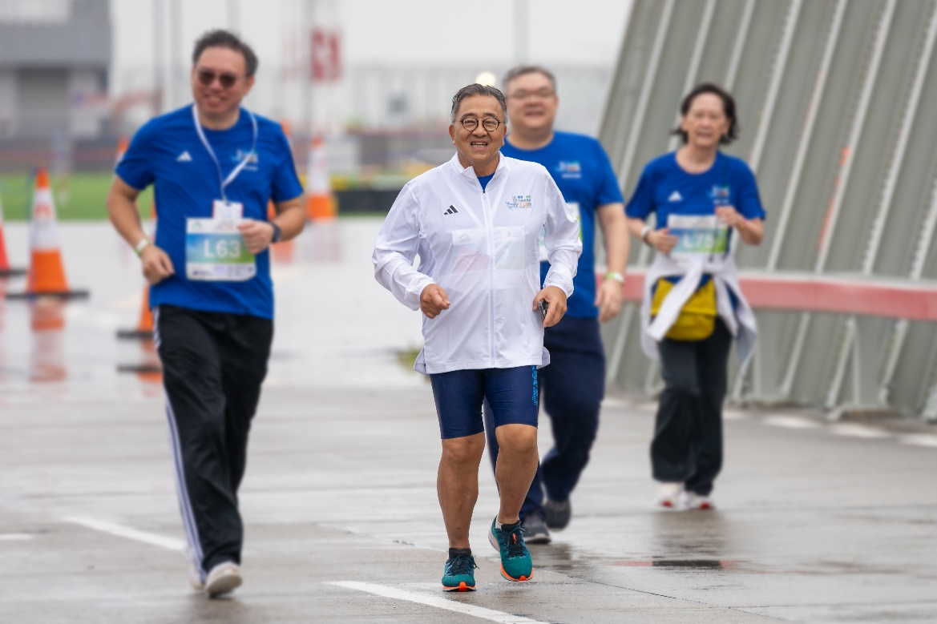
Mr. Song Hoi See, Founder and CEO of PPG, participated in the HKIA Leaders Cup with other local business and aviation leaders

[HONG KONG - 22 November, 2024] Plaza Premium Group (PPG), the leading global airport hospitality services provider, participated in the “Three-Runway System 10km International Race” at the Hong Kong International Airport as a sponsor. The event, which took place on 17th November, was co-presented by title sponsors Airport Authority Hong Kong and Standard Chartered Hong Kong, and organized by the Hong Kong, China Association of Athletics Affiliates.
This special edition of the Standard Chartered HK Marathon was held on the airport’s Centre Runway, offering participants a once-in-a-lifetime experience to race on the 3,800-metre-long runway before Hong Kong International Airport officially transitions to a three-runway system end of the month.
Mr. Song Hoi See, Founder and CEO of PPG, participated in the HKIA Leaders Cup with other local leaders from various sectors, including government, the Legislative Council, business, and the airport community. Additionally, over 50 people from the Plaza Premium Group team, including Mr. Jonathan Song and Ms. Mei Mei Song, Chief Commercial Officer and Chief Transformation Officer of PPG, joined the race alongside over 11,000 local and international runners through the newly built third runway prior to its opening amidst a fully operational airport, while Mrs. Linda Song, Executive Director of PPG, presented the awards for the 5km race Top 3 winners. This celebrated a major milestone in Hong Kong's aviation history.
The event was the second time that a race was hosted at the Hong Kong International Airport. 26 years ago, when the airport at Chek Lap Kok was inaugurated, the “Standard Chartered ’98 New Airport Marathon” was a milestone event, starting from the Tsing Ma Bridge and finishing on the airport runway. In that same year, Plaza Premium Group also began its journey in 1998 at the Hong Kong International Airport with the launch of Plaza Premium Lounge – the world’s first independent airport lounge. This race marked another milestone shared with Airport Authority Hong Kong.
“I am honored to have joined the Leaders Cup with other fellow leaders, of course, to be part of this landmark event together with the PPG team and share this special moment on the runway. Over the past 26 years, we have witnessed the growth and transformation of Hong Kong International Airport. We are proud to celebrate another major milestone in Hong Kong’s aviation history together, right where our journey began. We are excited to enter a new stage with them!” Said Mr. Song Hoi See, Founder and CEO, Plaza Premium Group.
Supporting this event reinforces PPG’s commitment to promote health and wellness within the community as part of its overall social impact initiative.
Leading the race for “Team PPG” was Jonathan Song, Chief Commercial Officer:
“We are delighted to be part of this unique event as an official sponsor. At PPG, we are committed to promoting health and wellness. This event served as a great opportunity for the airport community to connect through sports as well as to encourage our team to be active." said Jonathan.

Photos: (Download Here)
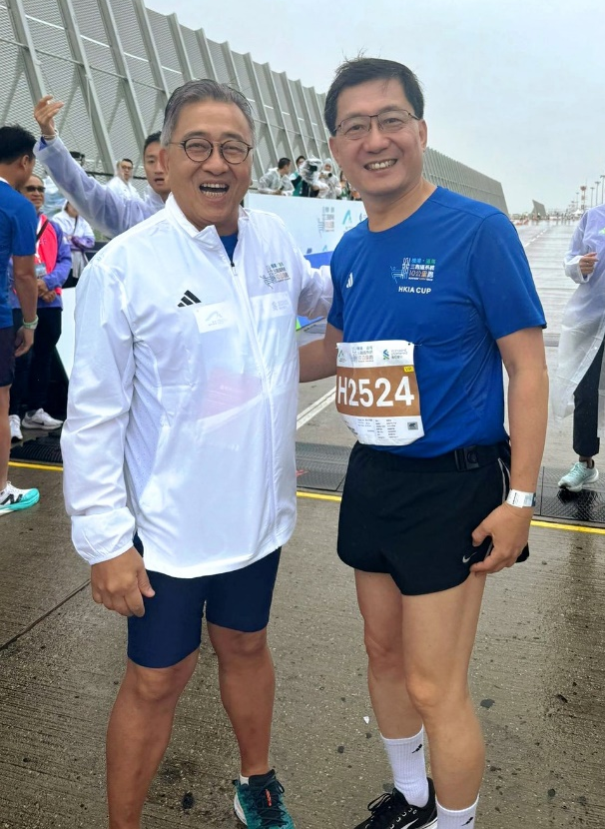 | 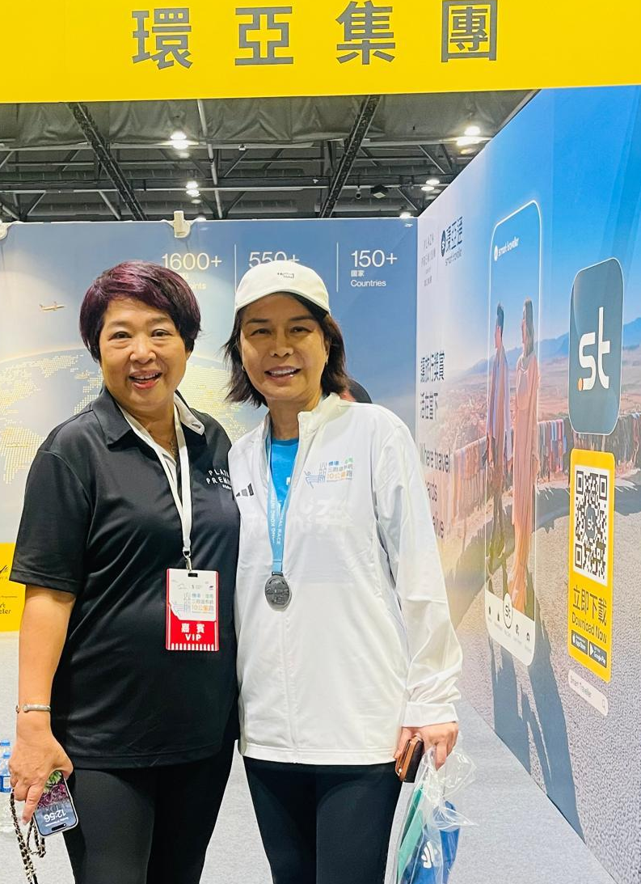
Mr. Song Hoi See, Founder and CEO of PPG with Mr. Fred Lam, Chairman of Airport Authority Hong Kong | Mrs. Linda Song, Executive Director of PPG, with Mrs. Vivian Cheung, Acting Chief Executive Officer of Airport Authority Hong Kong

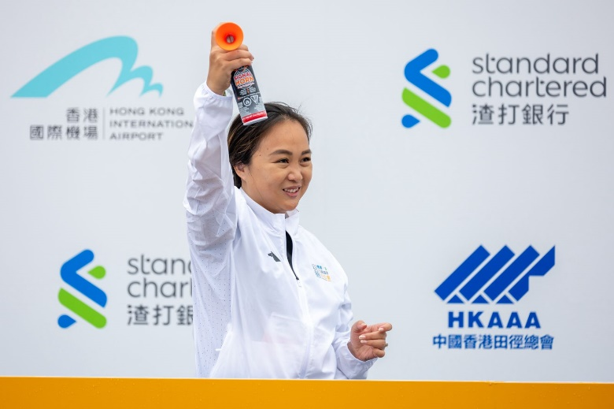 | 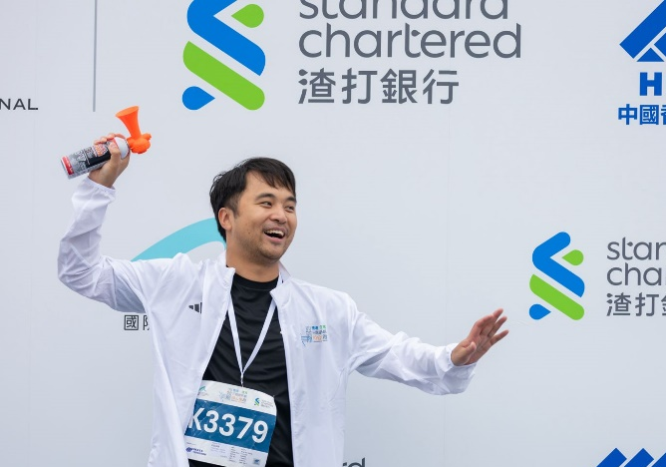
Ms. Mei Mei Song, Chief Transformation Officer of PPG, and Mr. Jonathan Song, Chief Commercial Officer of PPG, fired the starter pistol for the race

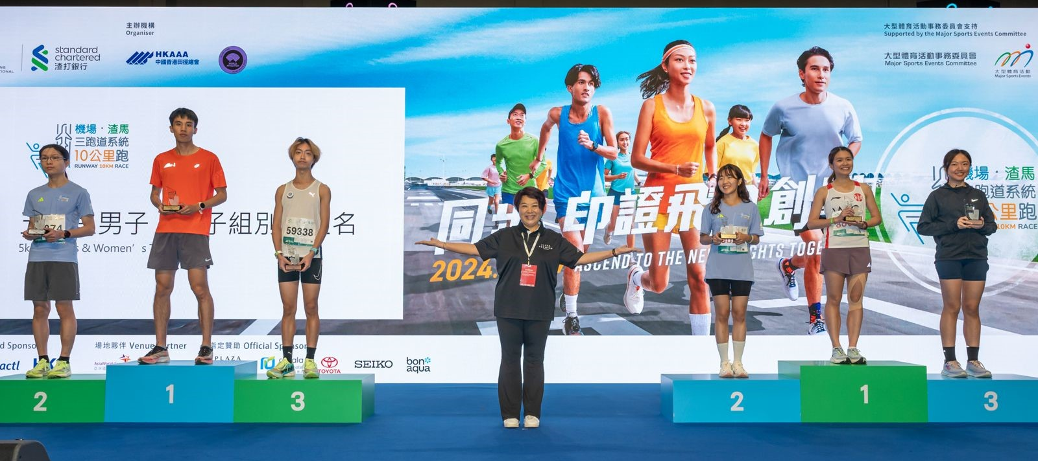Mrs. Linda Song, Executive Director of PPG, presented the awards for the 5km race Top 3 winners
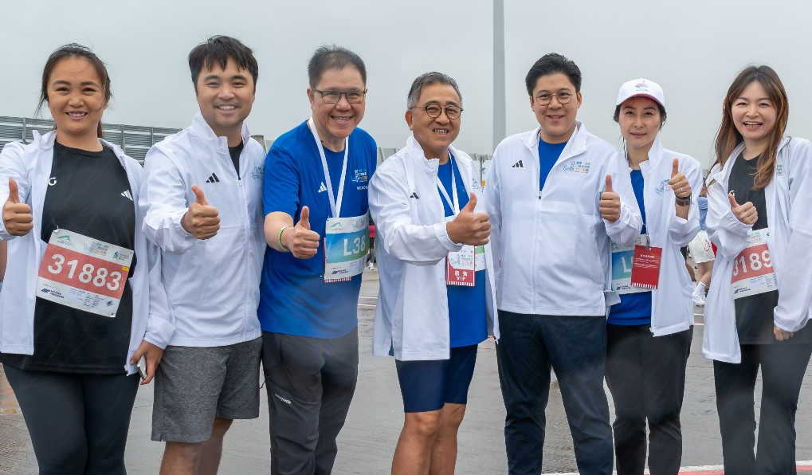
The Plaza Premium Group team with Mr. Cheong Shin Keong, Vice Chairman at ViuTV, Mr Kenneth Fok, Vice-President of the Sports Federation & Olympic Committee of Hong Kong, China, and Ms. Guo Jingjing, former diver and 4-time Olympic Gold Medallist.
(Left to right: Ms. Mei Mei Song, Chief Transformation Officer of PPG; Mr. Jonathan Song, Chief Commercial Officer of PPG; Mr. Cheong Shin Keong, Vice Chairman of ViuTV ; Mr Kenneth Fok, Vice-President of the Sports Federation & Olympic Committee of Hong Kong, China, and Ms. Guo Jingjing, former diver and 4-time Olympic Gold Medallist; Gigi Cheung, Managing Director of global marketing, products and partnerships of PPG)
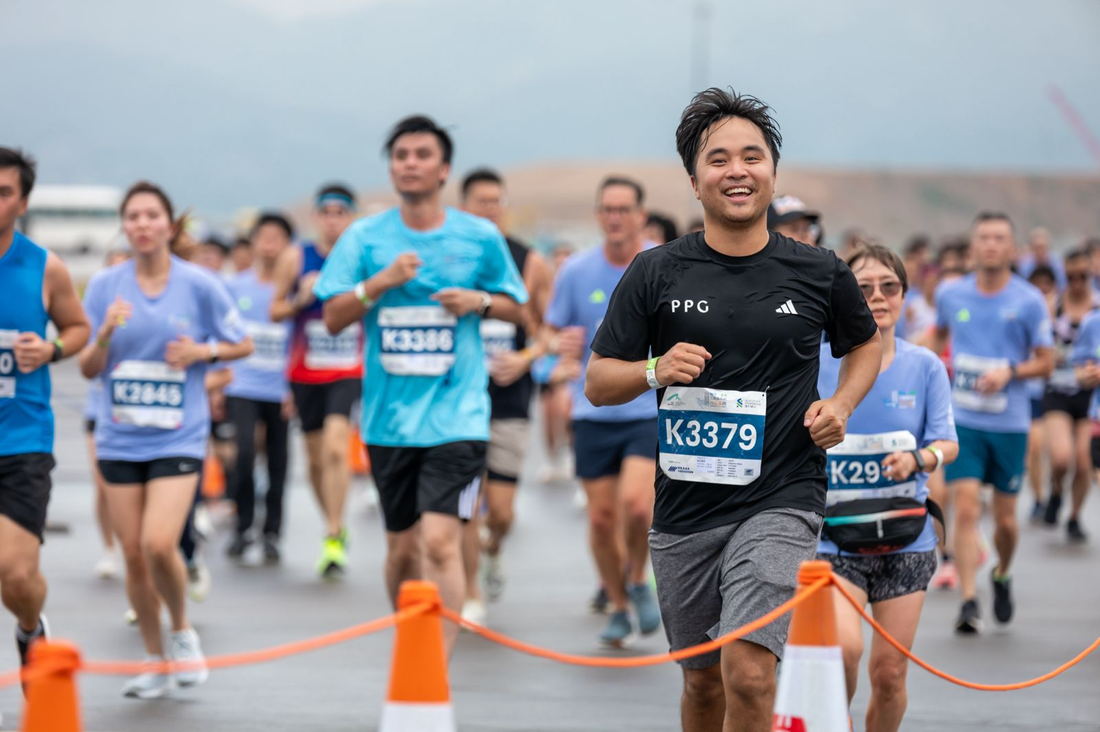
Mr. Jonathan Song, Chief Commercial Officer of PPG, participated at the 10km race

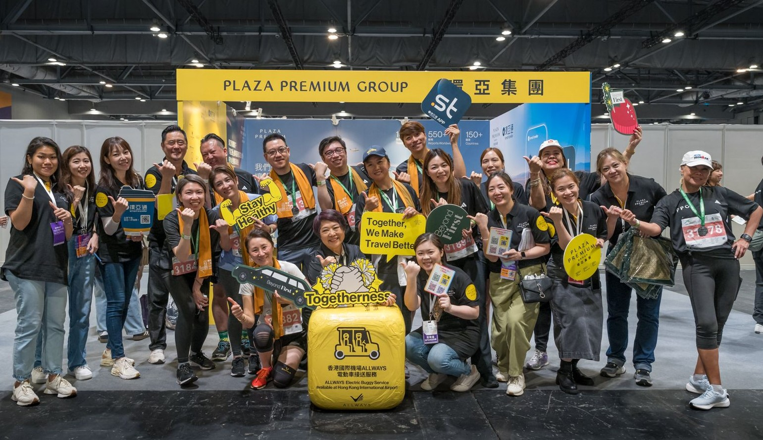
Over 50 team members of PPG participated in the race

Media Contact:
Whitney Fung
Plaza Premium Group PR & Corporate Communications
whitney.fung@plaza-network.com

About Plaza Premium Group
Plaza Premium Group, headquartered in Hong Kong and established in 1998, is a pioneering global airport hospitality services provider. With a mission to Make Travel Better, the group introduced the world's first independent airport lounge concept.
Today, PPG operates the largest network of international airport lounges worldwide and offers a 360-degree airport experience with 14 brands under its portfolio, spanning over 1,600 touchpoints in 150 countries across 600 international and domestic airports. From airport lounge brands - Plaza Premium Lounge & Plaza Premium First, to terminal hotels - Aerotel & Refreshhh by Aerotel, to concierge services - ALLWAYS, a range of airport dining concepts, global reward and membership program - Smart Traveller, and travel experience ECOsystem - oneTECO, the group is at the forefront of transforming airport experience for the better through innovative and human-led solutions. PPG’s commitment extends beyond its brands, as it also provides lounge management and hospitality solutions to leading airlines, alliances, and corporates worldwide. Partnerships include renowned names such as American Express, Capital One, Cathay Pacific Airways, SkyTeam, Star Alliance, Visa, and many more.
Plaza Premium Group has over 100 accolades demonstrating its exceptional achievements and commitment to service excellence. Notably, the group has received the prestigious "World's Best Independent Airport Lounge" award at the World Airline Awards by Skytrax for eight consecutive years from 2016 to 2024. TTG Asia also recognized the group as the "Best Airport Lounge Operator" in 2018, 2019 and 2023. In 2020, it achieved the "ISO 9001:2015" certification for its Hong Kong Headquarters. Furthermore, the group's Founder and CEO, Mr. Song Hoi-see, was awarded the “Ernst & Young Entrepreneur of the Year” and “Master Entrepreneur of the Year Malaysia” in 2018.
With a team of over 5,000 dedicated talents, PPG serves more than 20 million global passengers annually. Through a continuous pursuit of innovation and excellence, the group is experiencing exponential growth globally.
To learn more: https://www.plazapremiumgroup.com/

Connect with us: FB, IG, @plazapremiumlounge and WeChat @PlazaPremiumGroup

