Elevating the Travel Experience: Plaza Premium Group Unveils Dual Lounge Concept at Vancouver International Airport
This new concept debuts the launch of Plaza Premium First in North America and the new Canadian flagship lounge

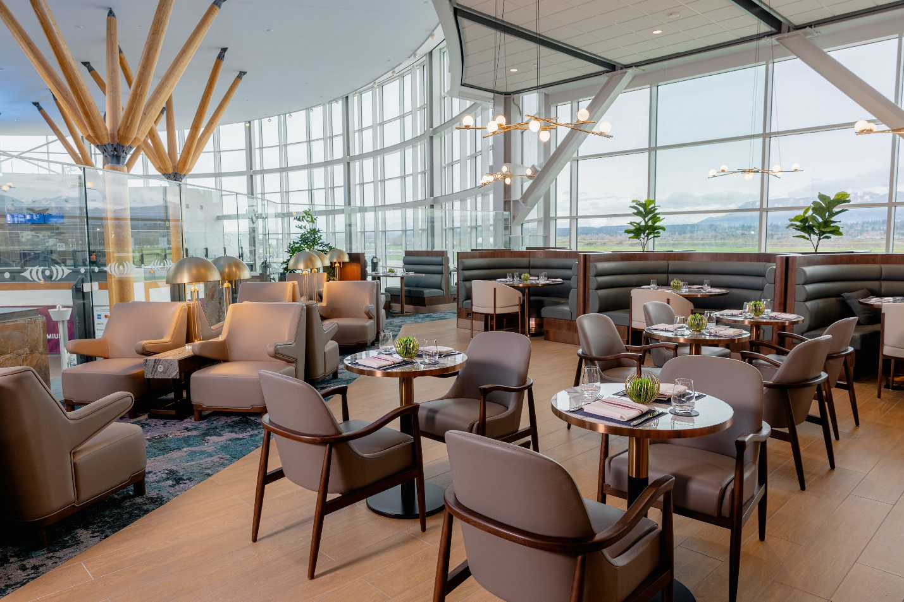

VANCOUVER, BC—[December 5, 2024]— Plaza Premium Group (PPG), the global leader in airport hospitality, proudly unveils its new Canadian flagship lounge at Vancouver International Airport (YVR). This milestone launch introduces the first-ever Plaza Premium First (PPF) in North America, alongside a reimagined Plaza Premium Lounge (PPL), delivering a dual-concept facility that caters to a variety of traveller needs—from luxury seekers to business travellers and families.

PPG’s newly reimagined and integrated concept, combining PPL and PPF, is the third of its kind worldwide, following successful launches at Jakarta Soekarno-Hatta Airport in December 2022 and Kuala Lumpur International Airport in March 2023. With additional locations at Hong Kong International Airport and Macau International Airport, PPF now operates five exclusive lounges worldwide.

"The launch of our new flagship lounge at Vancouver International Airport marks a significant milestone for Plaza Premium Group," said Pascal Bélanger, Senior Vice President of the Americas at Plaza Premium Group. "We are thrilled to introduce Plaza Premium First to North America, offering travellers an unparalleled level of luxury and personalized service that sets a new standard in airport hospitality. As we expand our presence across the Americas, our vision remains clear: to enhance the airport experience for travellers worldwide. This new lounge at YVR embodies that vision, seamlessly blending innovation, luxury, and personalized service to redefine what an airport lounge can be.”

Located in YVR’s International Terminal, the lounge spans nearly 1,000 square meters and accommodates 251 guests. The Plaza Premium Lounge features 136 seats, while Plaza Premium First offers an exclusive 115-seat space for travellers desiring a bespoke airport experience.
The reimagined flagship PPL is designed to offer a welcoming environment for all travellers, regardless of airline or class. Key features include:
- Interactive Live Cooking Stations: Seasonal menus featuring rotating options like noodle bars, pasta bars, and a signature poutine station.
- Family-Friendly Amenities: A welcoming section for family, offering board games on request and a "Mama’s Room" for nursing mothers.
- Self-Service Bar: Featuring a selection of soft drinks, juices, locally sourced wines and beer from BC partners and a selection of spirits for guests to enjoy at their leisure.
- Shower Facilities: Premium showers are available at an additional charge of CAD 25.

For travellers seeking a truly elevated experience, PPF, officially opening on December 2, 2024, is the pinnacle of airport hospitality. This premium offering provides a sanctuary for those who value privacy, exceptional service, and comfort. Key highlights include:

- Refined A La Carte Dining: A gourmet menu featuring signature dishes like Crab Omelette and Vegan Thai Curry, complemented by a premium buffet.
- Full-Service Bar: A curated selection of top-shelf spirits, fine wines, champagne, and handcrafted cocktails, including seasonal sustainable zero-waste creations.
- Spa-Like Amenities: Complimentary showers and private relaxation areas provide a serene escape before departure.

Thoughtfully designed with wellness, convenience and sustainability at its core, both lounges offer quiet zones for privacy and relaxation along with complimentary WiFi, international charging ports conveniently accessible from your seat or table, and Flight Information Displays Screens (FIDS) to keep guests informed. Culinary offerings are crafted to support balanced travel, including vegetarian and vegan options, alongside fresh pastries, desserts and cookies made daily. Committed to sustainability, the lounges are 100% ADA compliant, practice single-use plastic, practice sustainable seafood through Ocean Wise and proudly supports local food providers.

“I am pleased to welcome the first North American location of the Plaza Premium First lounge – the fifth of its kind globally, and a great addition to the travel experience at YVR,” said Tamara Vrooman, CEO of Vancouver International Airport. “Imagine stepping into a haven of luxury and comfort before your international flight, where a wide array of amenities and offerings await you. Indulge in exquisite local cuisine, stay connected with cutting-edge technology, and unwind in an atmosphere designed for maximum comfort.”

The new lounge celebrates Vancouver’s vibrant community through PPG’s Global Proudly Local initiative, highlighting the city’s finest art, food, and service while partnering with local purveyors. Inspired by British Columbia’s natural beauty, it features floor-to-ceiling windows that flood the space with natural light and showcase breathtaking mountain views, alongside intricate wallpaper designs, a soothing colour palette, and curated art by local artist Ken Prescott. This thoughtfully designed space invites guests to relax and connect with the region’s essence, embodying PPG’s vision of a destination before departure.

"Vancouver is a city rich in culture and natural beauty, and we are proud to reflect that in our new lounge,” adds Bélanger. “By integrating local art, cuisine, and design elements, we offer our guests a true taste of what makes this city unique, all while providing the world-class service they expect from Plaza Premium Group."

Both PPF and PPL are open to all travellers, with PPF access starting from CAD $110 and PPL from CAD $69 for 2-hour lounge access (tax excluded). Both lounges can be reserved online through the booking page or accessed via walk-in. Located in the International Terminal between Gate D67 and D68 on Level 4, the lounge operates seven days a week from 6:30 a.m. to 1:30 a.m. PST, with flexibility based on flight schedules.

Starting December 2, to celebrate the launch of PPF, travellers can enjoy a 30% discount on lounge access for their companions, applicable via online bookings only for a limited time.

For more information, please visit www.plazapremiumlounge.com. To book your destination before departure at the YVR International Plaza Premium Lounge, visit the Booking Page.

For high-res images: DOWNLOAD HERE

###

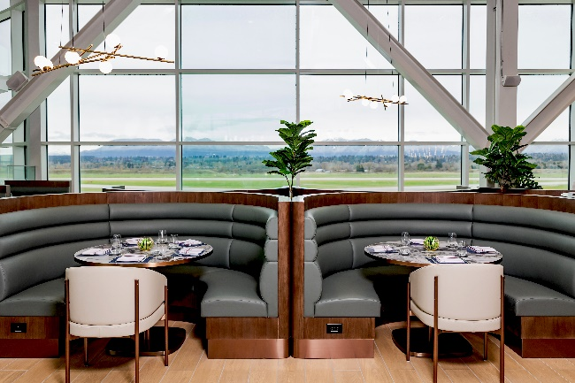 | 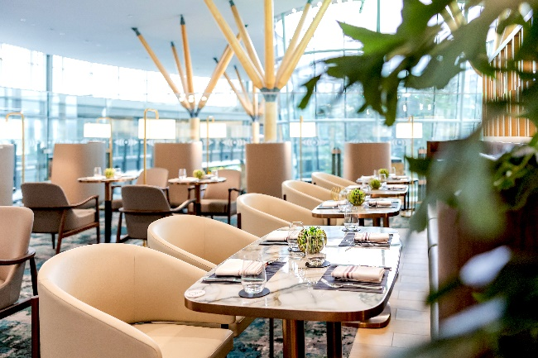
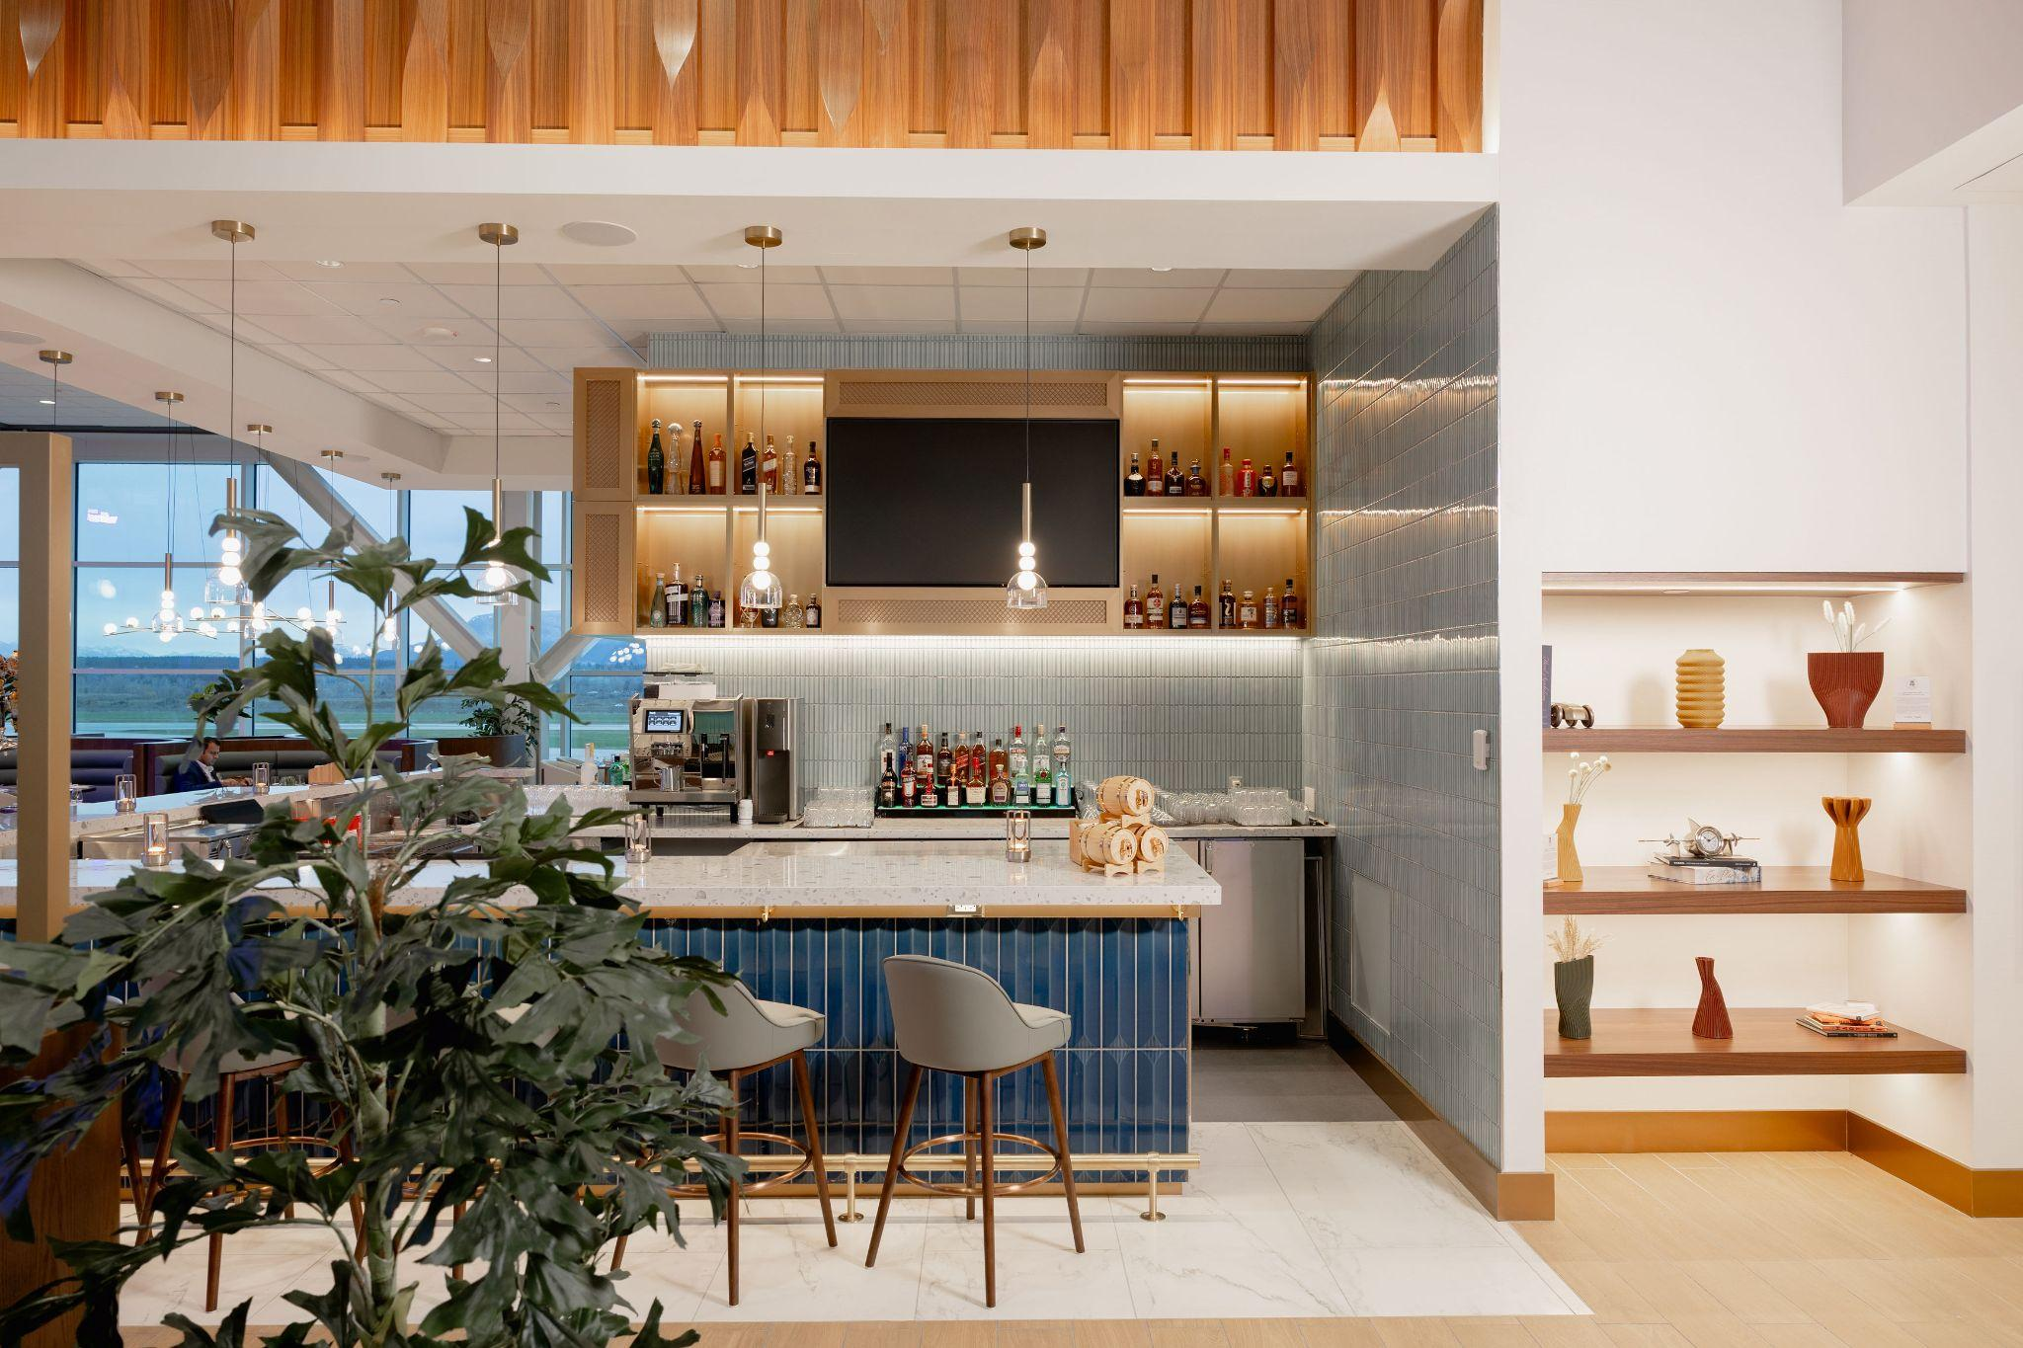 | 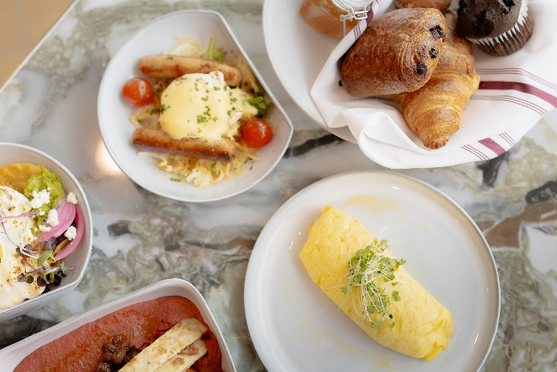
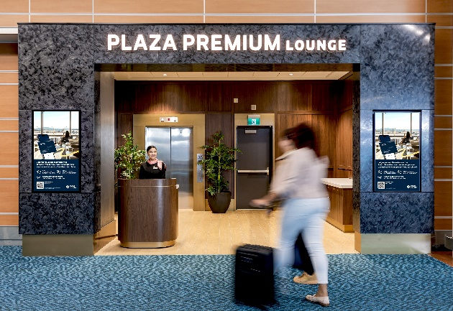 | 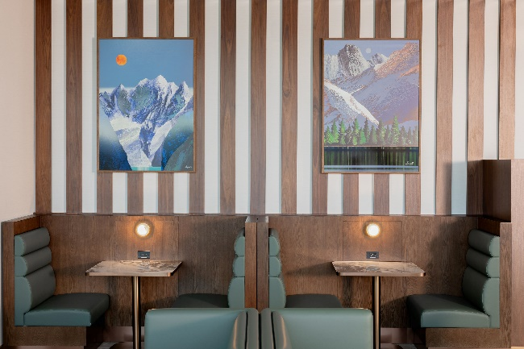

About Plaza Premium Group
Plaza Premium Group, headquartered in Hong Kong and established in 1998, is a pioneering global airport hospitality services provider. With a mission to Make Travel Better, the group introduced the world's first independent airport lounge concept.

Today, PPG operates the largest network of international airport lounges worldwide and offers a 360-degree airport experience with 14 brands under its portfolio, spanning over 1,600 touchpoints in 150 countries across 600 international and domestic airports. From airport lounge brands - Plaza Premium Lounge & Plaza Premium First, to terminal hotels - Aerotel & Refreshhh by Aerotel, to concierge services - ALLWAYS, a range of airport dining concepts, global reward and membership program - Smart Traveller, and travel experience ECOsystem - oneTECO, the group is at the forefront of transforming airport experience for the better through innovative and human-led solutions. PPG’s commitment extends beyond its brands, as it also provides lounge management and hospitality solutions to leading airlines, alliances, and corporates worldwide. Partnerships include renowned names such as American Express, Capital One, Cathay Pacific Airways, SkyTeam, Star Alliance, Visa, and many more.

Plaza Premium Group has over 100 accolades demonstrating its exceptional achievements and commitment to service excellence. Notably, the group has received the prestigious "World's Best Independent Airport Lounge" award at the World Airline Awards by Skytrax for eight consecutive years from 2016 to 2024. TTG Asia also recognized the group as the "Best Airport Lounge Operator" in 2018, 2019 and 2023. In 2020, it achieved the "ISO 9001:2015" certification for its Hong Kong Headquarters. Furthermore, the group's Founder and CEO, Mr. Song Hoi-see, was awarded the “Ernst & Young Entrepreneur of the Year” and “Master Entrepreneur of the Year Malaysia” in 2018.

With a team of over 5,000 dedicated talents, PPG serves more than 20 million global passengers annually. Through a continuous pursuit of innovation and excellence, the group is experiencing exponential growth globally.

To learn more: www.plazapremiumgroup.com and www.plazapremiumlounge.com
Connect with us: FB, IG, @plazapremiumlounge and WeChat @PlazaPremiumGroup

Media Contact
Whitney Fung
whitney.fung@plaza-network.com
Plaza Premium Group PR & Corporate Communications

