Plaza Premium Group Celebrates Multiple Recognitions with Three Industry Awards in China
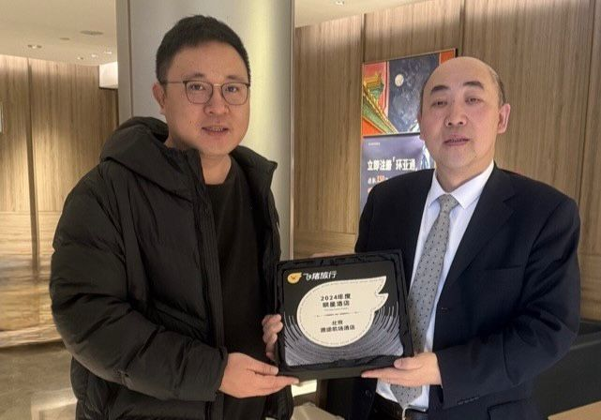 | 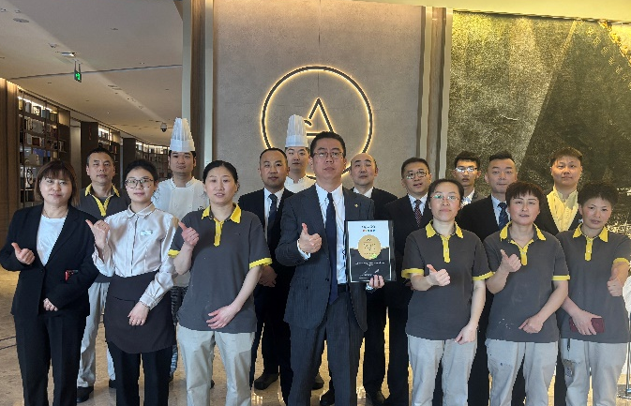
Mr. Su Yan Peng, Business Development Manager of Fliggy, presented the "Star Hotel Award 2024" to Mr. Zhu Nan, Front Office Manager of Aerotel Beijing. | Allan Fu, General Manager of Aerotel Beijing and Team
[11th February 2025 - China] – Plaza Premium Group (PPG), the leading global airport hospitality services provider, announces its recent achievement of receiving three industry awards in China.
Aerotel Beijing, located at Beijing Daxing International Airport, has received two recognitions from major online travel platforms – Agoda and Fliggy respectively, following its recent win as the "Best Airport Hotel Award 2024" at the CHA China Hotel Awards.
Fliggy, a leading online travel platform in China under Alibaba group, has honored Aerotel Beijing with the "Star Hotel" award. This award is judged based on the quality of guest experiences and reviews which aims to recognize hotels with outstanding performance in service quality, customer satisfaction, and innovation capabilities. Aerotel Beijing was previously awarded by Fliggy for two consecutive years with the “Best Partner of the Year” in 2019 and 2020.
In addition, Aerotel Beijing has received the Gold Circle Award by Agoda, one of the top global online travel agencies. Every year since 2009, Agoda has selected and recognized a small, elite group of property partners who have distinguished themselves with superior value for customers, world-class service, and a strong partnership with Agoda over the past year. This marks Aerotel Beijing's first Agoda Award.
Aerotel, Plaza Premium Group’s airport hotel brand, has been has been consistently offering exceptional airport experiences to passengers with flexible hourly bookings, quality services, and welcoming environments since its inception in 2016. To date, Aerotel has established locations in ten popular destinations globally, including Beijing, Qingdao, Kuala Lumpur, Cebu, Singapore, Sydney, Rio De Janeiro, London, Muscat, and Jeddah, with a new one set to open at Shanghai Pudong International Airport in the second quarter of 2025.
Other than hotel awards, Ms. Cheng Dan, Guest Service Officer of Plaza Premium Lounge Chongqing, has been recognized with the "Customer Service Star Award 2024" by Chongqing Jiangbei International Airport. This accolade represents the lounge's first-ever award since its opening in 2024.
These awards demonstrate PPG’s commitment to deliver excellent service for passengers: "We are honored to have received these invaluable industry awards, these recognitions motivate us to keep making travel better. Our heartfelt gratitude extends to our partners, customers, and team members. As we continue to expand our presence across China, we remain committed to enriching our offerings, creating award-winning airport experiences, and setting a new standard for excellence within the country and beyond.” Ms. Jenny Zhang, Regional General Manager of North Asia.
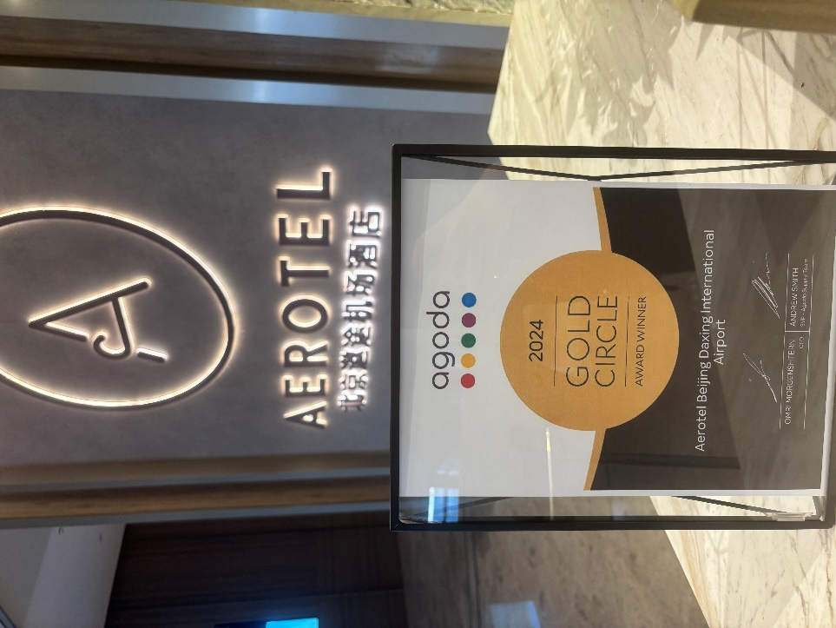
Aerotel Beijing has received the Gold Circle Award by Agoda.

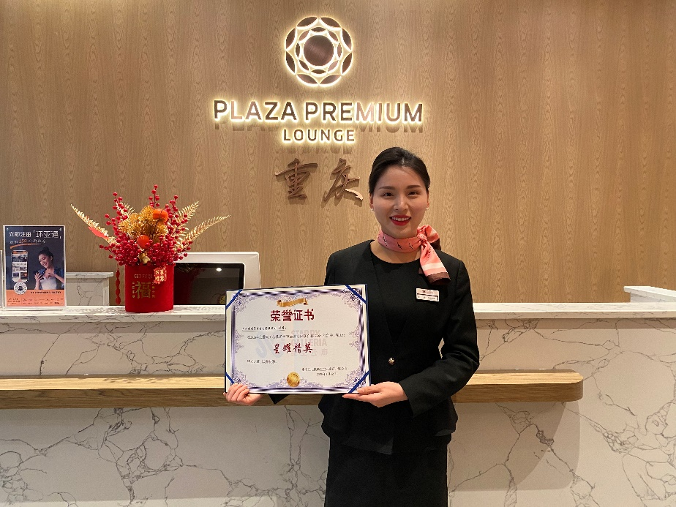
Ms. Cheng Dan, Guest Service Officer of Plaza Premium Lounge Chongqing, has been recognized with the "Customer Service Star Award 2024" by Chongqing Jiangbei International Airport.

Download high-res photos here

About Plaza Premium Group
Plaza Premium Group, headquartered in Hong Kong and established in 1998, is a pioneering global airport hospitality services provider. With a mission to Make Travel Better, the group introduced the world's first independent airport lounge concept.
Today, PPG operates the largest network of international airport lounges worldwide and offers a 360-degree airport experience with 14 brands under its portfolio, spanning over 1,600 touchpoints in 150 countries across 600 international and domestic airports. From airport lounge brands - Plaza Premium Lounge & Plaza Premium First, to terminal hotels - Aerotel & Refreshhh by Aerotel, to concierge services - ALLWAYS, a range of airport dining concepts, global reward and membership program - Smart Traveller, and travel experience ECOsystem - oneTECO, the group is at the forefront of transforming airport experience for the better through innovative and human-led solutions. PPG’s commitment extends beyond its brands, as it also provides lounge management and hospitality solutions to leading airlines, alliances, and corporates worldwide. Partnerships include renowned names such as American Express, Capital One, Cathay Pacific Airways, SkyTeam, Star Alliance, Visa, and many more.
Plaza Premium Group has over 100 accolades demonstrating its exceptional achievements and commitment to service excellence. Notably, the group has received the prestigious "World's Best Independent Airport Lounge" award at the World Airline Awards by Skytrax for eight consecutive years from 2016 to 2024. TTG Asia also recognized the group as the "Best Airport Lounge Operator" in 2018, 2019 and 2023. In 2020, it achieved the "ISO 9001:2015" certification for its Hong Kong Headquarters. Furthermore, the group's Founder and CEO, Mr. Song Hoi-see, was awarded the “Ernst & Young Entrepreneur of the Year” and “Master Entrepreneur of the Year Malaysia” in 2018.

With a team of over 6,000 dedicated talents, PPG serves more than 20 million global passengers annually. Through a continuous pursuit of innovation and excellence, the group is experiencing exponential growth globally.
To learn more: https://www.plazapremiumgroup.com/
Connect with us: FB, IG, @plazapremiumlounge and WeChat @PlazaPremiumGroup

